Project for CSE821

Study of temporal constraint network
Computer Science Department, UNL

Lin Xu

Abstract

Temporal constraint networks are kind of very important constraint satisfaction problems (CSP), which involves variables having continuous domains. In Temporal constraint satisfaction problem (TCSP), variable represent time points and temporal information (constraint) is represented by a set of permitted intervals.
In this report, we study two kinds of temporal problems, simple temporal problems (STP) and general temporal problems (TCSP). The first one only admits at most one interval constraint on any pair of time points. We use All-pairs-shortest-path algorithm (Floyd-Warshall’s algorithm) and DPC algorithm to solve the STP. Depending on the attribute of the constraint network, we try to add some heuristic to improve the performance of those algorithms. For general TCSP, it allows each pair of time points has more than one interval. The basic way to solve TCSP is backtracking search, we implement backtracking search and add some heuristics to make it more efficiency. The result shows those techniques are helpful to solve STP and TCSP problems.

- Introduction
There are lots of problems involving with time interval, time point in computer science such as scheduling, parallel computation. To solve those problems, several formalisms for expressing and reasoning about temporal knowledge have been proposed.
In this paper, we represent our TCSP problem as:
Variable: Set of time points, X₁, … X_{n}, which tell the time point that event happened.
Constraints: The intervals between two events. (For STP, only has one time interval)
{I₁, I₂, I₃, … I_{n}}={[a₁, b₁], … [a_{n}, b_{n}]}

For example:
John goes to work either by car (30-40 min) or by bus (at least 60 min). Fred goes to work either by car (20-30 min), or in a carpool (40-50 min). Today john left home between 7:10 and 7:20, Fred arrived at work between 8:00 and 8:10. We also know that John arrived at work about 10-20 min after Fred left home [1].
The variables are some time point, such as left home time for john. The constraints are the intervals between those time points. Since intervals between two time points are more than one, for example: the intervals between left home time and arrived work time are 30-40 min or at least 60 min, this problem is a general TCSP.
For this problem, we can ask: “Is the information consistent?” “Is it possible that John took bus and Fred used the carpool” “What are the possible times at which Fred left home?” and so on.
In this paper, we only focus on a binary TCSP: A network of binary constraints consists of a set of variables, X₁, X₂, … X_{n}, and a set of unary and binary constraints. Such a network can be represented by a directed constraint graph. In this graph, nodes represent variables and edges indicate constraints between variables. A special time point X₀ is used to show the beginning of the world. The constraint graph for the example is given below.
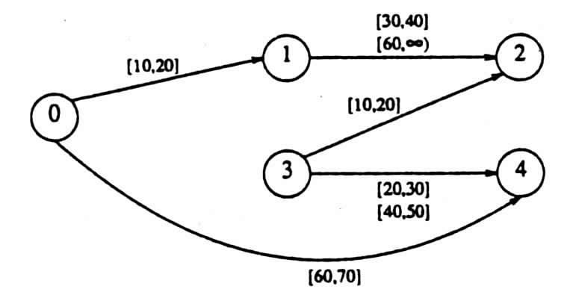
Fig. 1. A constraint graph represents the example [1].

The solutions for a TCSP are the tuples X={x₁, … x_{n}}. Such that {X₁=x₁, … X_{n}=x_{n}} satisfies all the constraints. If there exists a solution in which X_{i}=v, value v is called a feasible value for variable X_{i}. All feasible values of variable are called the minimal domain. The constraint network is consistent if and only if there exist at least one solution.

- The simple temporal problem (STP)

If every constraint in a TCSP only has one interval, we call this TCSP a simple temporal problem (STP). So we can represented the constraint as:
C_{ij} = [a_{ij}, b_{ij}]
a_{ij} ≤ X_{j}-X_{i} ≤ b_{ij}.
We can represent our STP with a directed edge-weighted graph called a distance graph (G_{d}). The node in the d-graph has the same meaning as constraint graph. The edge, i→j, in the distance graph is labeled by a weight b_{ij}, which means X_{j}-X_{i} ≤ b_{ij}. So for each constraint, we need two edges: X_{j}-X_{i} ≤ b_{ij} and X_{i}-X_{j} ≤ -a_{ij}. If we skip some intervals (make it become a STP), our example can be represented as figure 2.
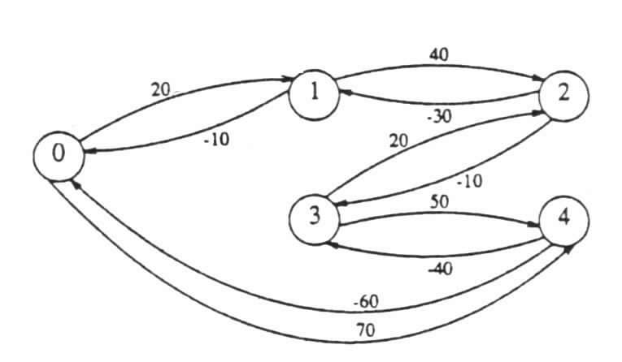
Fig. 2. A distance graph represents a part of the example [1].

To solve STP, one way is to find the shortest paths in the distance graph. The d-graph of an STP can be built by using Folyd-Warshall’s all-pairs-shortest-paths algorithm [2] to the distance graph.
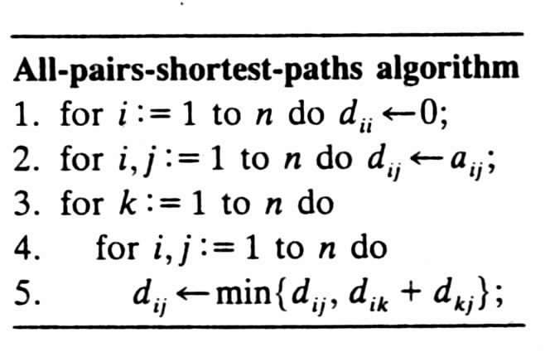
Fig. 3. Folyd-Warshall’s algorithm [1].
This algorithm runs in time O(n³), and if there exists negative cycles, the problem is inconsistent [5]. By running this algorithm, we can get the minimal domains and the minimal network.
If we only interest in if the problem is consistent, we can run DPC algorithm [3] instead of Folyd-Warshall’s all-pairs-shortest-paths algorithm. DPC is similar to PC-1, but it is a single pass algorithm. DPC is an algorithm enforcing directional path consistency, it only look for future variable, so it needs less time than Folyd-Warshall, but it cannot get the minimal network.
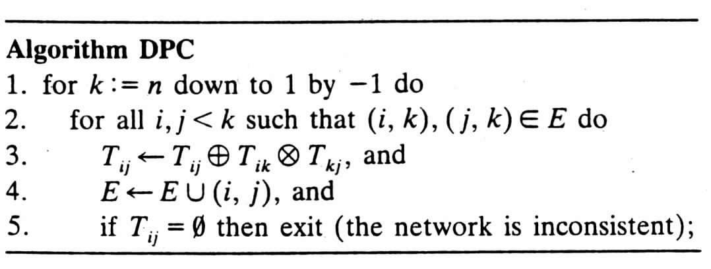
Fig. 4. DPC algorithm [1].

- The general TCSP

General TCSP has more than one interval for each constraint. To solve TCSP, we can consider it composed by several STP. Consider a TCSP with 10 edges and each edge has 5 intervals, we can make this TCSP become 10⁵ STP. Davis showed that determining consistency for a general TCSP is NP-hard [6].
Normally, we solve TCSP using backtracking search (Fig. 5). There are two procedures: Forward and Go-back. The first extends a current partial assignment if possible, and the second handles dead-end situations. The worst-case complexity of this algorithm is O(n³k^{e}).
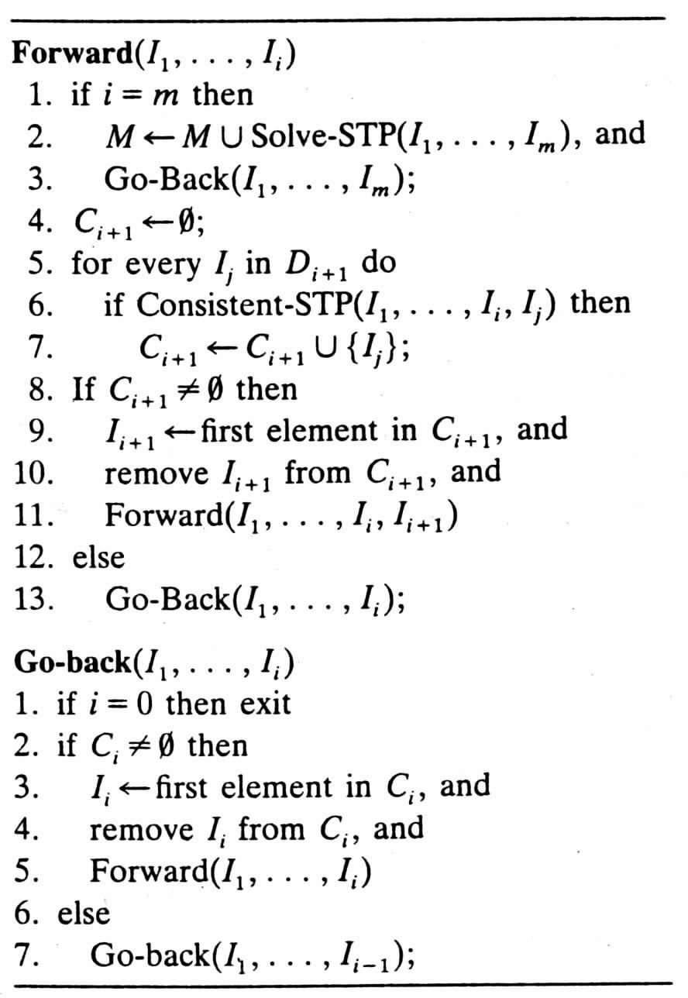
Fig. 5. Backtrack algorithm to solve TCSP [1].

- Improvement
Since TCSP is NP-hard in general, we want to find some technical to improve the algorithm.
- If a TCSP is inconsistent, there exist a negative cycle. But the negative cycle only can be caused by a cycle. Which means a tree structure always consistent. So, if there is no cycle (or there is no new cycle), the problem will remain consistent.
- If a graph has some separation vertexes (articulation points), this graph is called separable [4]. We can depart this graph to some nonseparable components, and solve each one of them independently. If all the components are found to be consistent, then the entire network is consistent, and the minimal networks of the individual components coincide with the overall minimal network.

- Experimental

To compare those algorithms, we use four kinds of random CSP problem generator to generate sets of random STP and TCSP problems.
a. For STP problems:
STP-genertor-1: Random selects the edges and random select the interval for the edges. Since the interval is random selected, most of those problem exists negative cycles and have no solution [5].
STP-genertor-2: Random selects n points from a line. Then based on those points, random select an interval include this point. So those problems are consistent. To make those problems not always have solution, there is ¼ chance to change the intervals of two edges (then the problem may inconsistent).
b. For TCSP problems:
TCSP-genertor-1: Random selects the edges and the intervals. The number of intervals for each edges no more than 5. Most of those problems have no solution.
TCSP-genertor-2: Like STP, the second one random select n points from a line. Then based on those points, select an interval include the point. Finally, add at most 4 intervals to each edge. It also has ¼ chance to change two edges to make it inconsistent.

Using this two generator, we generate 100 examples for each point.
For STP, we use variable number 50 and generate 10 points (d= 0.01, 0.02, … 0.1, with step 0.01). After testing with our algorithms (STP-solver, STPplus-solver, DPC-solver, DPCplus-solver), we use the average value for our result. We focus on the CPU-time and constraint checks.
For TCSP, we use variable number 8 and generate 13 points (d= 0.02, 0.04, … 0.1 with step 0.02 and d=0.2, … 0.9 with step 0.1). After testing with our algorithms (TCSP-solver, TCSPplus-solver, TCSPPplus-solver), we use the average value for our result. We check the node visited, constraint checks and CPU time.

The Table 1 below shows our algorithms to solver TCSP problems:

Problem type | Name | Basic algorithm | Improvement
STP | STP-solver | Folyd-Warshall | NONE
STP | STPplus-solver | Folyd-Warshall | 2
STP | DPC-solver | DPC | NONE
STP | DPCplus-solver | DPC | 2
TCSP | TCSP-solver | BT, DPC | NONE
TCSP | TCSPplus-solver | BT, DPC | 1
TCSP | TCSPPplus-solver | BT, DPC | 1,2

Table 1. Different solver for STP and TCSP.

- Result

All the results are list in those tables below.

P | STP-solver |  | STPplus-solver |  | DPC-solver |  | DPCplus-solver
 | cc | cpu | cc | cpu | cc | cpu | cc | cpu
0.01 | 55575 | 0.9 | 12350.58 | 0.33 | 21675.76 | 0.13 | 4181.73 | 0.13
0.02 | 42813.5 | 0.71 | 19028.53 | 0.44 | 14044.25 | 0.08 | 5043.62 | 0.15
0.03 | 33808.5 | 0.57 | 23296.02 | 0.51 | 9803.8 | 0.06 | 4533.81 | 0.14
0.04 | 28671 | 0.5 | 23956.31 | 0.52 | 7351.28 | 0.05 | 4429.26 | 0.14
0.05 | 26873.5 | 0.46 | 23594.69 | 0.5 | 5780.61 | 0.04 | 3260.02 | 0.13
0.06 | 21548 | 0.37 | 23686.95 | 0.49 | 3366.21 | 0.03 | 2285.52 | 0.11
0.07 | 20903 | 0.36 | 20743.52 | 0.45 | 3186.56 | 0.02 | 2487.95 | 0.11
0.08 | 16856.5 | 0.31 | 19239.72 | 0.44 | 2678.91 | 0.02 | 2089.15 | 0.11
0.09 | 15301 | 0.28 | 18578.49 | 0.42 | 2123.18 | 0.02 | 1520.13 | 0.11
0.1 | 14247 | 0.27 | 16813.02 | 0.4 | 1521 | 0.02 | 1286.99 | 0.06

Table 2. The results (constraint checks and CPU time) of solving STP.
(The examples generate by the STP-generator-1)

P | STP-solver |  | STPplus-solver |  | DPC-solver |  | DPCplus-solver
 | cc | cpu | cc | cpu | cc | cpu | cc | cpu
0.01 | 122926 | 1.92 | 29033 | 0.58 | 39967 | 0.32 | 9352 | 0.25
0.02 | 122368 | 1.98 | 60972 | 1.13 | 39880 | 0.55 | 19464 | 0.79
0.03 | 117912 | 1.83 | 76585 | 1.3 | 38343 | 0.74 | 24444 | 1.14
0.04 | 115974 | 1.95 | 89403 | 1.62 | 37910 | 1.19 | 28743 | 2
0.05 | 116975 | 1.83 | 101533 | 1.7 | 39121 | 1.43 | 32697 | 2.49
0.06 | 118750 | 2.03 | 107746 | 1.94 | 39040 | 2.08 | 34852 | 3.45
0.07 | 118983 | 1.88 | 110345 | 1.84 | 38632 | 2.32 | 36328 | 3.71
0.08 | 115372 | 1.98 | 112333 | 2.03 | 37944 | 2.82 | 35414 | 4.54
0.09 | 113331 | 1.79 | 112022 | 1.87 | 37195 | 2.98 | 35273 | 4.48
0.1 | 116739 | 1.94 | 115299 | 2.03 | 38721 | 3.92 | 37976 | 5.91

Table 3. The results (constraint checks and CPU time) of solving STP.
(The examples generate by the STP-generator-2)

P | TCSP-solver |  |  | TCSPplus-solver |  |  | TCSPPplus-solver
 | nc | cc | cpu | Nc | cc | cpu | nc | cc | cpu
0.02 | 7 | 81 | 0 | 7 | 0 | 0 | 0 | 0 | 0
0.04 | 140 | 3709 | 0.23 | 140 | 610 | 0.07 | 9 | 73 | 0.01
0.06 | 213 | 5338 | 0.31 | 213 | 890 | 0.09 | 19 | 152 | 0.01
0.08 | 409 | 9912 | 0.69 | 409 | 2391 | 0.25 | 52 | 445 | 0.04
0.1 | 555 | 18019 | 1.05 | 555 | 5312 | 0.41 | 149 | 1930 | 0.13
0.2 | 1754 | 77184 | 4.34 | 1754 | 25225 | 1.77 | 881 | 11497 | 0.84
0.3 | 3188 | 116780 | 7.33 | 3188 | 54975 | 3.85 | 1794 | 33310 | 2.31
0.4 | 5472 | 237584 | 14.51 | 5472 | 147015 | 10.38 | 4792 | 140247 | 9.64
0.5 | 7070 | 321161 | 19.64 | 7070 | 161512 | 11.4 | 7000 | 164152 | 11.7
0.6 | 7143 | 323352 | 19.83 | 7143 | 180469 | 12.33 | 6724 | 190318 | 12.86
0.7 | 9241 | 448672 | 27.36 | 9241 | 236015 | 15.79 | 8693 | 222129 | 15.34
0.8 | 10792 | 494756 | 30.23 | 10792 | 322661 | 20.6 | 9082 | 267824 | 17.19
0.9 | 7198 | 316781 | 19.22 | 7198 | 189840 | 12.27 | 8658 | 244170 | 15.72

Table 4. The results (node visited, constraint checks and CPU time) of solving TCSP.
(The examples generate by the TCSP-generator-1)

P | TCSP-solver |  |  | TCSPplus-solver |  |  | TCSPPplus-solver
 | nc | cc | Cpu | Nc | cc | cpu | nc | cc | cpu
0.02 | 22135 | 758889 | 31.29 | 22135 | 0 | 3.18 | 0 | 0 | 0
0.04 | 24109 | 909572 | 43.25 | 24109 | 220264 | 14.48 | 292 | 5428 | 0.24
0.06 | 27277 | 1215407 | 57.68 | 27277 | 368321 | 22.54 | 4148 | 96017 | 5.28
0.08 | 27277 | 1215407 | 57.68 | 27277 | 368321 | 22.54 | 4148 | 96017 | 5.28
0.1 | 26305 | 1071484 | 53.01 | 26305 | 349868 | 21.85 | 2929 | 67731 | 3.63
0.2 | 20748 | 872757 | 43.81 | 20748 | 316313 | 19.9 | 7866 | 140137 | 8.36
0.3 | 25408 | 1076837 | 52.75 | 25408 | 431881 | 25.79 | 19776 | 341282 | 20.4
0.4 | 21850 | 874900 | 42.55 | 21850 | 382335 | 21.16 | 18885 | 351956 | 19.32
0.5 | 21002 | 821941 | 41.18 | 21002 | 353670 | 20.27 | 20494 | 361953 | 20.44
0.6 | 19115 | 810623 | 39.12 | 19115 | 323162 | 18.65 | 20654 | 373897 | 21.08
0.7 | 21806 | 1092349 | 50.98 | 21806 | 456915 | 24.97 | 21500 | 444559 | 24.25
0.8 | 29192 | 1303950 | 63.35 | 29192 | 454819 | 26.85 | 28483 | 450477 | 26.85
0.9 | 28593 | 1362764 | 65.47 | 28593 | 550674 | 30.22 | 28025 | 554384 | 30.23

Table 5. The results (node visited, constraint checks and CPU time) of solving TCSP.
(The examples generate by the TCSP-generator-2)

- Analysis and discuss

a. STP
Next figure shows the constraint checks and CPU time of solving STP with different algorithms (The data comes from STP-generator-2, Table 3).
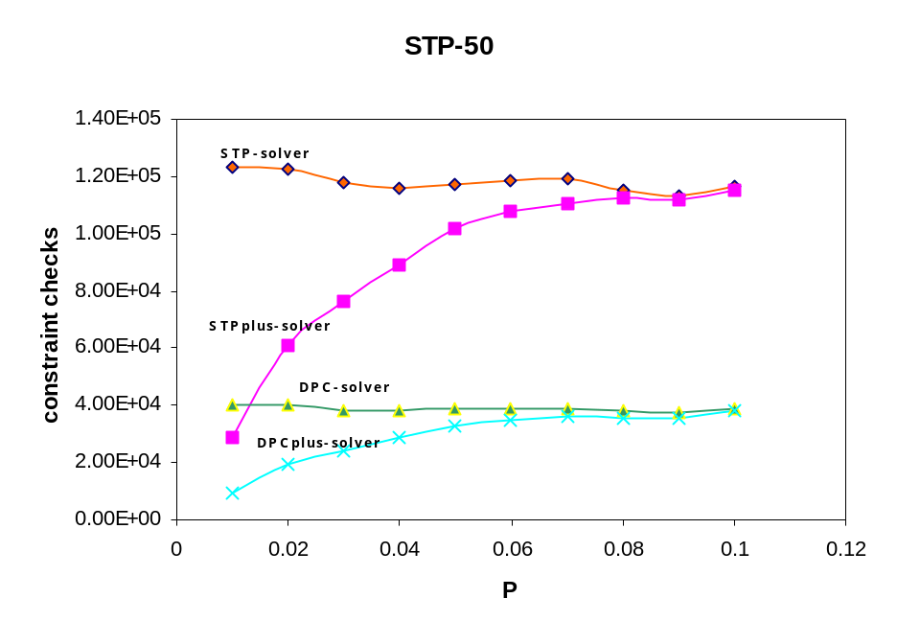
Fig. 6. Constraint checks using different algorithm to solve STP.
(Data comes from Table 3)

From Figure 6, we can find that when the density is lower, the different between PLUS method and normal method is bigger in constraint checks. The reason is when density is low, which means there are fewer edges in the constraint graph. So the possibility to find articulation point is high. There is more chance for the graph can be separated. If the problem can become two smaller sub-problem, solve those two smaller problems are much easier than solve the original bigger one. For example, suppose we use Folyd-Warshall algorithm. The complexity are O(n³). One big problem with 10 nodes needs 1000 units’ recourses. If we can instead the big one with two smaller one, the total cost only 125+125=250. But when the density becomes high, there are more edges in the constraint graph. Most likely, the graph can’t be separated. So the two methods almost have the same constraint checks.
Since DPC only check the future variable, so it always needs fewer constraint checks than Folyd-Warshall algorithm. But it needs some complex function such as combination. The CPU-time in some case is higher than Folyd-Warshall algorithm.
If we use the STP examples generate by STP-generator-1 (Table 2), we can find some interesting result by comparing Fig. 6 and Fig. 7.
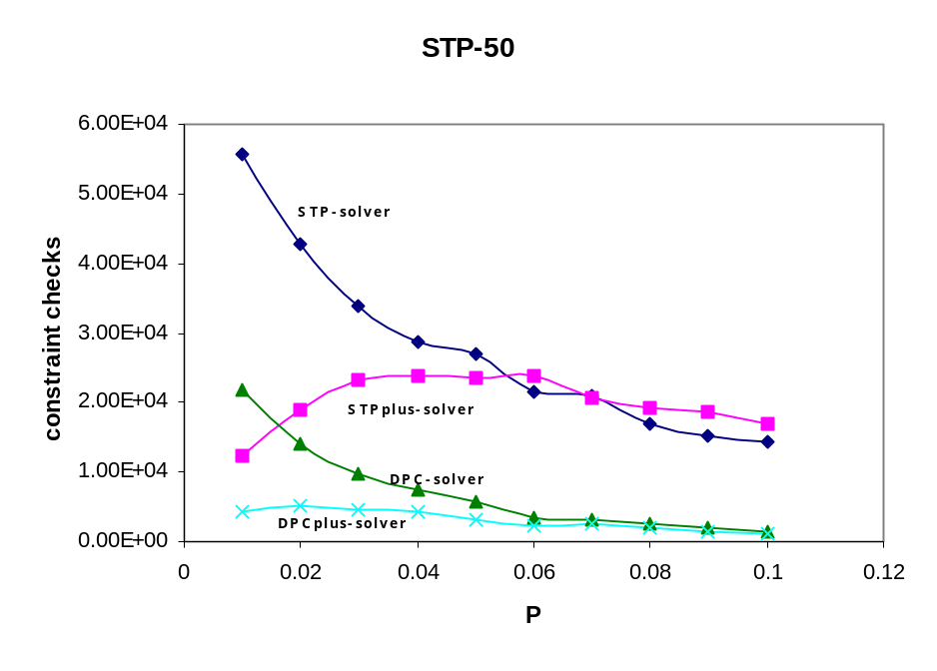
Fig. 7. Constraint checks using different algorithm to solve STP.
(Data comes from Table 2)

Solving STP with low density needs more constraint checks than solving STP with high density. The reason is that most of the problems generated by STP-genertor-1 are inconsistent. When density is low, there are fewer cycles. So it is harder to find negative cycle with very few cycles. When density become higher, it is easy find a negative cycle and stop. Interesting thing is the PLUS algorithms still needs fewer constraint checks when density is lower. Consider the PLUS algorithms used the Improvement 2. This improvement will part the graph with nonseparable components. There are only two kinds of nonseparable components, one is cycle and the other is two points line. Since we never check tree structure, PLUS can very quickly finds the cycle, check them and find the negative cycle then stop. The fact is that the nodes insider the cycle is fewer when density is low. So, PLUS algorithms needs more time to find inconsistent when density is high.

b. TCSP
In general, TCSP is a NP-hard problem. TCSP can’t solve within polynomial time. We use some techniques to improve the TCSP algorithm. The figure below shows the Node visited, constraint checks and CPU time using different methods (the examples comes from TCSP-generator-2, Table 5).
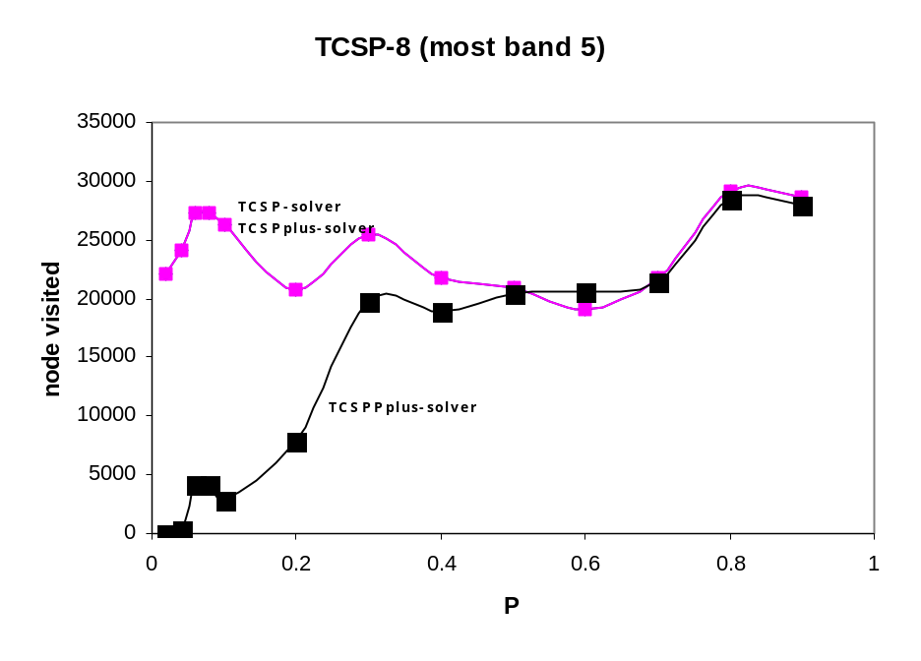
Fig. 8. Node visited for different TCSP solver.
(Data comes from Table 5)
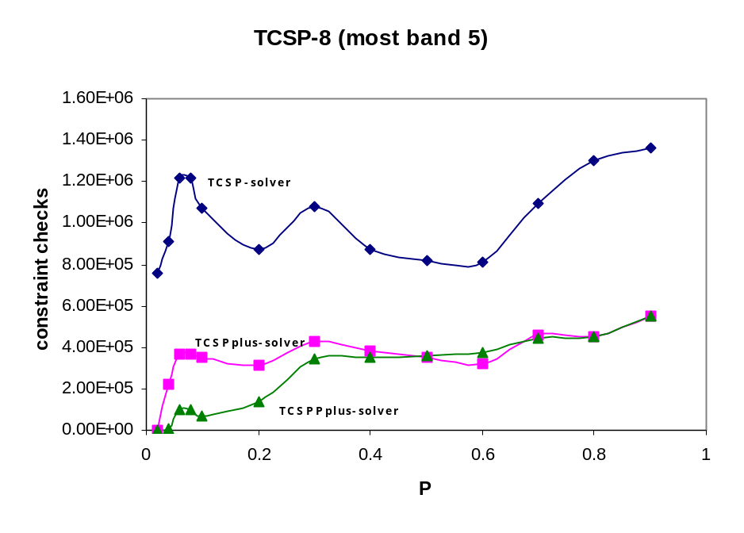
Fig. 9. constraint checks for different TCSP solver.
(Data comes from Table 5)
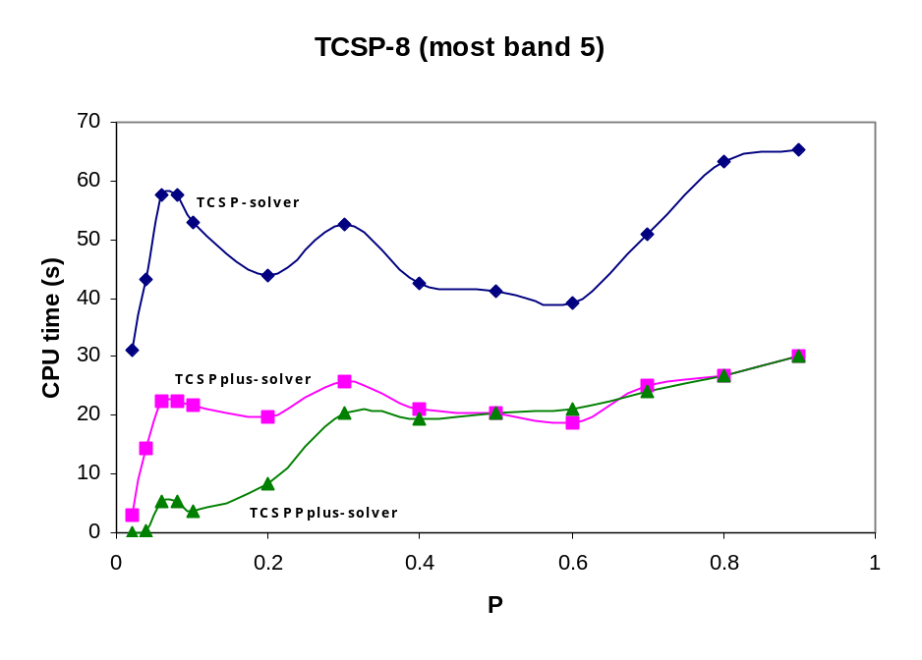
Fig. 10. CPU time for different TCSP solver.
(Data comes from Table 5)

From the graph, we can see that in general, TCSPPplus-solver always better than TCSPplus-solver and TCSPplus-solver always better than TCSP-solver.
We notice that TCSP-solver and TCSPplus-solver have the same number of node visited and TCSPPplus-solver has fewer nodes visited than the previous two. The different between TCSP-solver and TCSPplus-solver is that we use improvement 1 in TCSPplus-solver. If there is no new cycle, we don’t check them at all. But this only happened in the process “check”. It doesn’t affect the label and unlabal processes. The number of node visited will remain the same. As a result of not checking until there is new cycle, TCSPplus-solver always check less constraint and use less CPU time.
TCSPPplus-solver introduces new heuristic into search algorithm. Like STPplus and DPCplus, TCSPPplus first divide the constraint graph into some nonseparable components, then solve them independently. From the figure, we also can find that we the density is low, the TCSPPplus-solver much better than TCSPplus-solver, and when the density become high, this two almost the same.

- Conclusion

From those discuss above, we can draw conclusion:
- DPC checks less constraint than Folyd-Warshall, but it only can judge the problem is consistent or not.
- DPCplus and STPplus are much better than original one in constraint checks when the densities are low.
- TCSPplus has the same number of node visited, but always checks less constraint and needs less CPU time than TCSP.
- TCSPPplus is better than TCSPplus when density is low. When density is high, TCSPPplus looks like TCSPplus.

- Future work

There still have lots of work we can do. We can find the series-parallel network and which is backtrack-free. We can find the better variable ordering make the search more efficiency. We also want to consider the chance to use interchangeability into solving TCSP.

Reference
  - R. Dechter, I. Meiri, and J. Pearl, Temporal constraint networks,
Artif. Intell., 49 (1991) 61-95.
  - C.H. Papadimitriou and K. Steiglitz, combinatorial optimization: algorithms and complexity (Prentice-Hall, Englewood Cliffs, NJ, 1982)
  - R. Dechter and J. Pearl, Network-based heuristics for constraint-satisfaction problems, Artificial Intelligence, 34(1) (1987) 1-38.
  - S. Even, Graph Algorithms (computer Science Press, Rockville, MD, 1979).
  - R. Shostak, Deciding linear inequalities by computing loop residues,
Journal of the ACM, 28(4) (1981) 769-779.
  - E. Davis, Private communication (1989).

